Sentiment Classification System for Arabic/English Text Report
Grupe Names : Sajad Ali Idan & Gafar Ali Muter

TO : Dr.Akram Taha

Date : 10/12/2025

Executive Summary:

This carefully designed and categorized emotion tool is capable of determining whether a text is negative, positive, or biased. Using natural language processing and learning (NLP) techniques, the best model (a logistic regression model) achieved a final success rate of 71.55% on the test group.

(Introduction & Problem Statement):

Introduction: The importance of sentiment analysis in the modern business environment (customer reviews, social media).

The problem: The need for an accurate automated system for classifying emotions in [English/Arabic] due to the increasing volume of textual data.

The Goal: To build and compare sentiment classification models (Logistic Regression, Naive Bayes, Random Forest) and select the model with the highest performance.

Technical Methodology:

Dataset:

Description: Contains a custom dataset on [200 Samp] technical.

Distribution: It contains three classification categories: Positive, Negative, Neutral.

Training & Evaluation:

The basic models tested: Logistic Regression, Multinomial Naive Bayes, Random Forest

The metrics are: Accuracy, Precision per category, Recall, F1-Score, and Mixing Matrix.

Results and Discussion

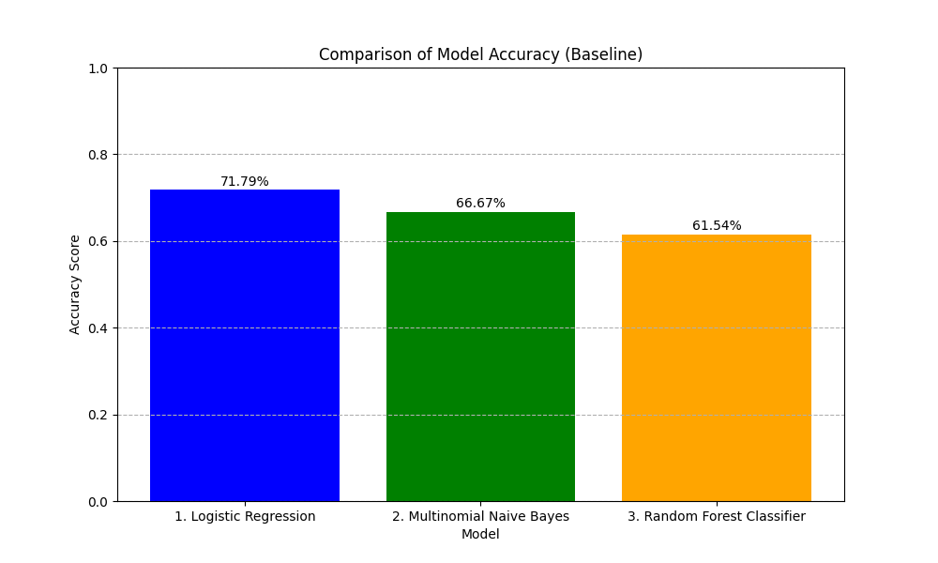
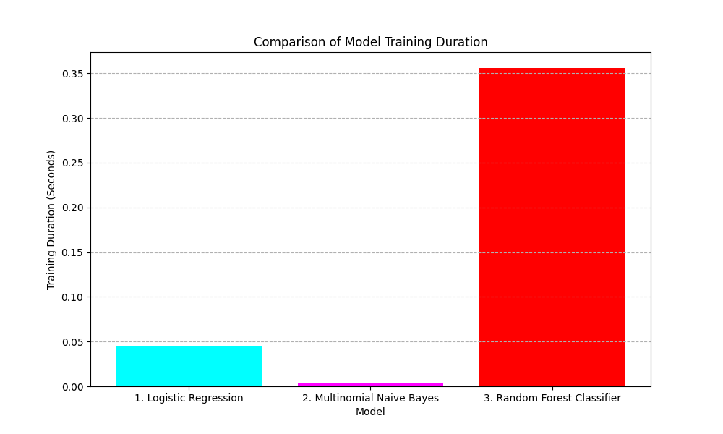

Conclusion & Recommendations

Summary:

Final result reaffirmation: The project objective was successfully achieved by the (Logistic Regression) model with an accuracy of 71.55%.

Recommendations for future improvement: [Suggest solutions, such as: increasing the data size to 1000 samples, or trying an SVM model.]

